**Artificial Neural Networks**

**What is Deep Learning ?**

The approach to Machine Learning characterized by the deep stack of computations is often called as Deep Learning.

The field of Deep Learning is a subdomain of Machine Learning which is being modeled by Artificial Neural Networks. Neural Networks are composed of neurons, where each neuron performs a simple mathematics computation.

**The Linear Unit (Neuron)**

The concept of **Artificial Neural Network** has been derived from the biological neural networks inside the human body. Similar to the human neurons ,in ANN the neurons are interconnected with each other. These neurons are known as nodes.

A simple biological neuron looks like this :

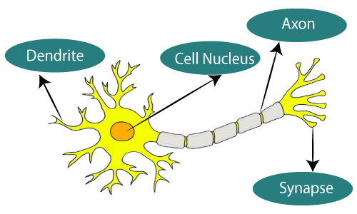

Whereas a neuron in a ANN looks like :

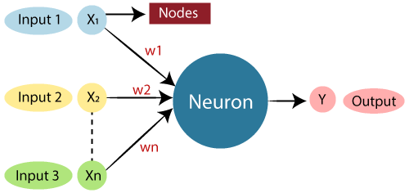

Where all the w’s are the weights and x’s are the inputs and the y is the computational output of the neurons.

**Layers in a ANN**

A simple ANN looks like the one given below , which basically consists of three layers, namely :

1. Input layer
2. Hidden layer
3. Output layer

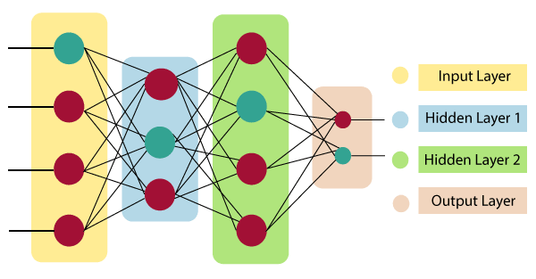

The above neural network consists of one input layer , two hidden layers and one output layer.

Input layer **:** As the name suggests it takes in different inputs provided by the programmer.

Hidden layer : It is present in between the input and the output layers.It performs all the actions that are taken on the input data to generate necessary outputs.

Output layer : The final output is released through this layer.

**How ANN works ?**

ANNs can be best represented as weighted directed graphs where the neurons form the nodes. The w(n) on the edges of these n number of neurons form the weights of these neurons. ANNs receive inputs from some external source as designed by the programmer. These inputs are not necessarily in the form of our desired form to act upon therefore the input data undergoes through certain transformations. These inputs are then mathematically assigned by the notations x(n) for every n number of inputs.

The weights can be thought as the magnitude of that connection of nodes. Therefore the weight is multiplied with its corresponding input to generate the necessary output:

For a linear unit with one input:

**y = x(w)+b**

Where b is the bias.It is added as an insurance if the weighted sum happens to be zero.

For a linear unit with three inputs :

**y = x0(w0)+x1(w1)+x2(w2)+b**

and so on .

Basically linear unit with one input represent : equation of line.

linear unit with two inputs represent : equation of plane.

linear unit with more inputs represent : equation of hyperplane.

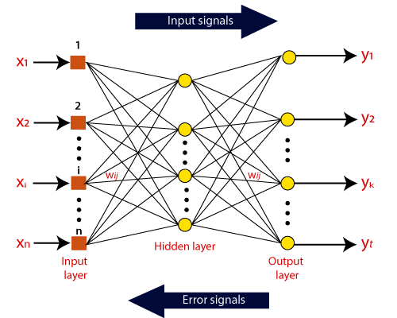

The outputs of the input layer is taken as the inputs by the first hidden layer, and the process keep going on until the final output is received.

**Backpropagation**

Backpropagation is one of the key feature behind the success of the Artificial Neural Networks. Backpropagation is a strategy in which the weights are adjusted in order to minimize the cost function.

It is the method of fine-tuning the weights of a neural network based on the error rate obtained in the previous epoch. The weights are adjusted again and the whole training is carried on.

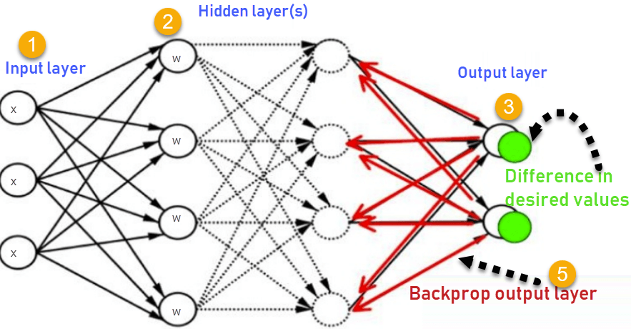

In a backpropagation algorithm :

1. Inputs X, arrive through the external source in case of input layer and from the previous perceptron in the hidden layer.
2. Input is modeled using real weights W. The weights are usually randomly selected.
3. The output for every neuron is collected from the input layer, to the hidden layers, to the output layer.
4. The error in the outputs is collected

**Error = Actual Output – Desired Output**

1. We travel back from the output layer to the hidden layer to adjust the weights such that the error is decreased.

Keep repeating the process until the desired output is achieved.

**Advantages of ANN**

1. Parallel processing capability.
2. Storing data on the entire network.
3. Capability to work with incomplete knowledge.
4. Having fault tolerance.

**Disadvantages**

1. Hardware dependence
2. Duration of learning is unknown
3. Difficulty in making the network understand the issue
4. Assurance of proper network structure.